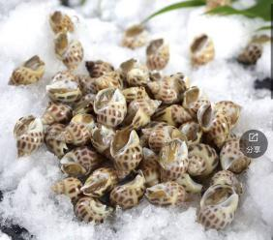 无沙花螺250g Y22.8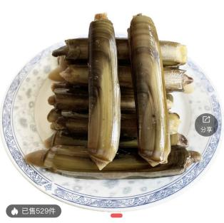山东竹蛏王500g /份Y12.8
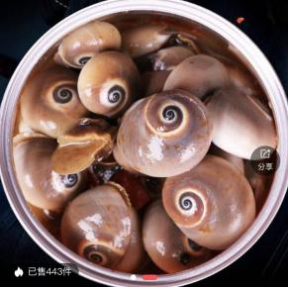满膏香螺500g/ Y 14.88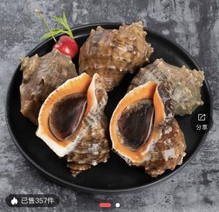鲜活海螺5个/份 Y17.8
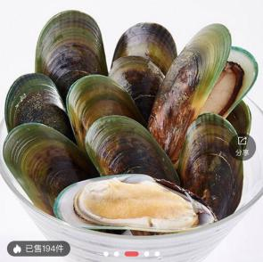新西岚贻贝500g Y27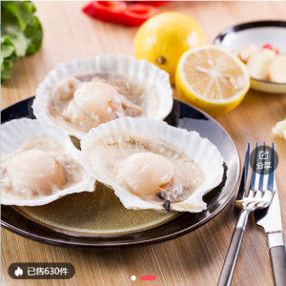特大鲜活扇贝6个/Y18.88
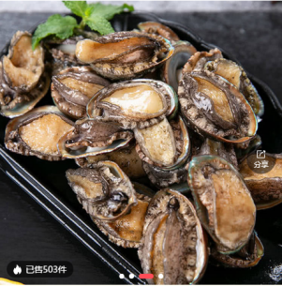鲜活鲍鱼6个/盒Y23.8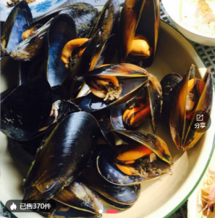鲜活海虹500g Y5.3
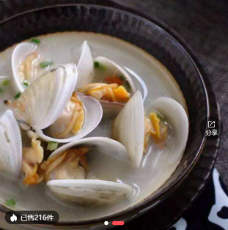黑蛤蜊500g/份13.88 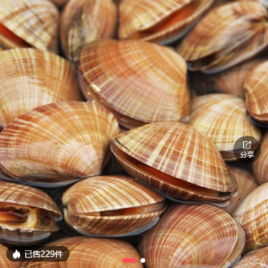黄蚬子500g/份Y16.8

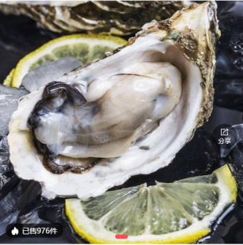鲜活乳山蚝2斤/Y16.8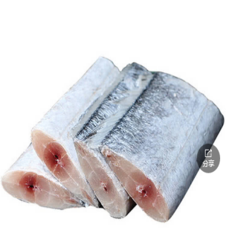冰鲜带鱼段700g/Y9.78

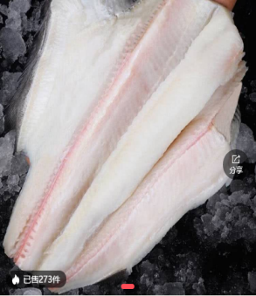鸦片鱼身1000-1250g Y86.8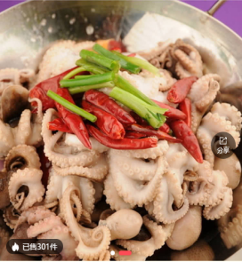小八爪鱼500g/份Y31.8
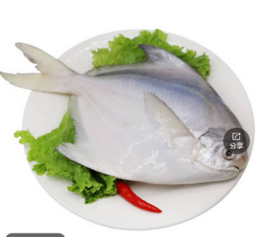冰鲳鱼3500g /Y55.8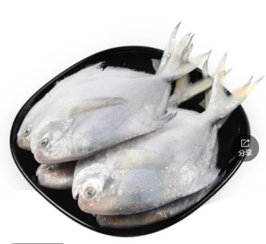冰鲜鲳鱼70-80g/条 13.8

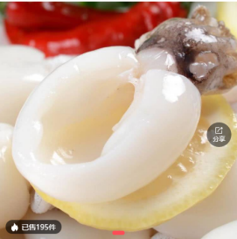鲜冻墨鱼仔900g/份Y28.8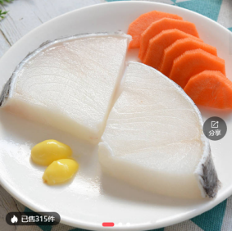深海鳕鱼300g/Y3.8
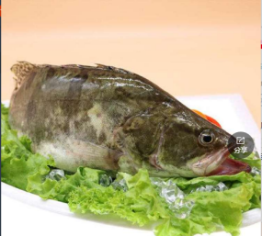鲜活桂鱼500g-600g/条38.8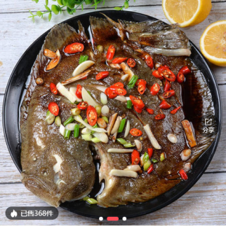多宝鱼450g/Y26.5
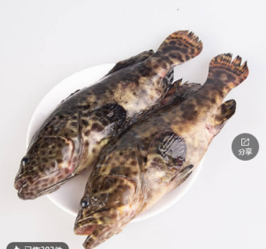鲜活石斑600g/Y35.8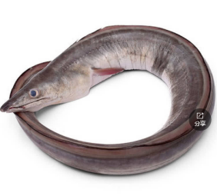鲜活鳗鱼600g/Y48.8
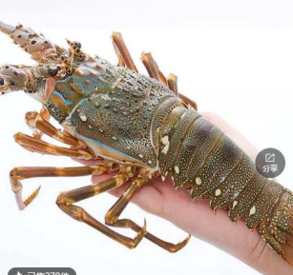鲜活小青龙250g/Y48.8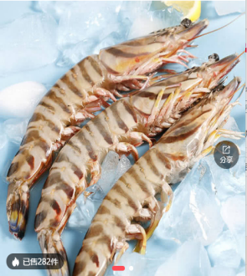大斑节虾30条/200g Y75

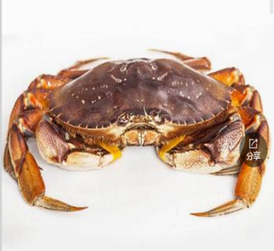珍宝蟹800g/Y105.8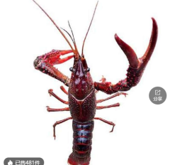小龙虾（3斤）/Y55.8
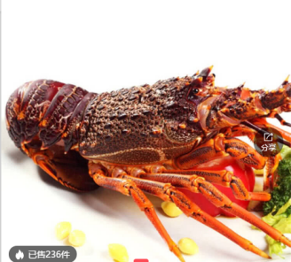鲜活澳龙只/Y398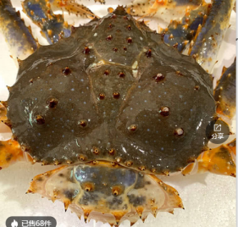帝王蟹3000g只/Y1549
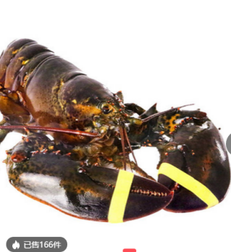大波龙650g/Y78.8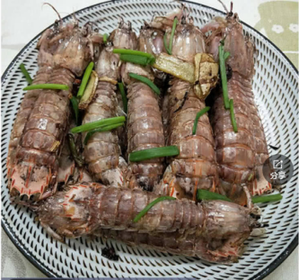皮皮虾400g/Y51.8
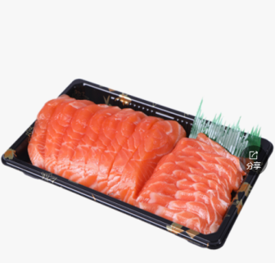三文鱼500g/Y79.8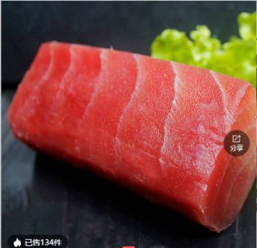金枪鱼刺身550g/Y47.8
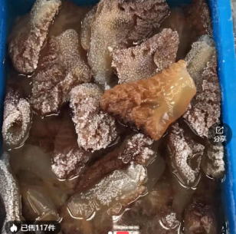海蜇头250g/Y24.8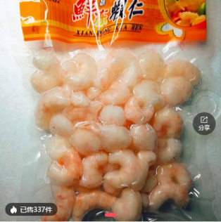冰冻虾仁130g/袋 Y12.8
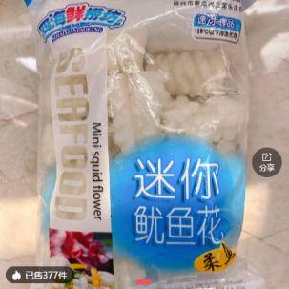鱿鱼花250g/包18.8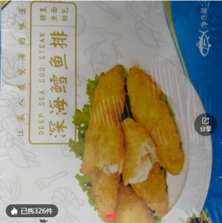雪鱼排310g/盒Y25

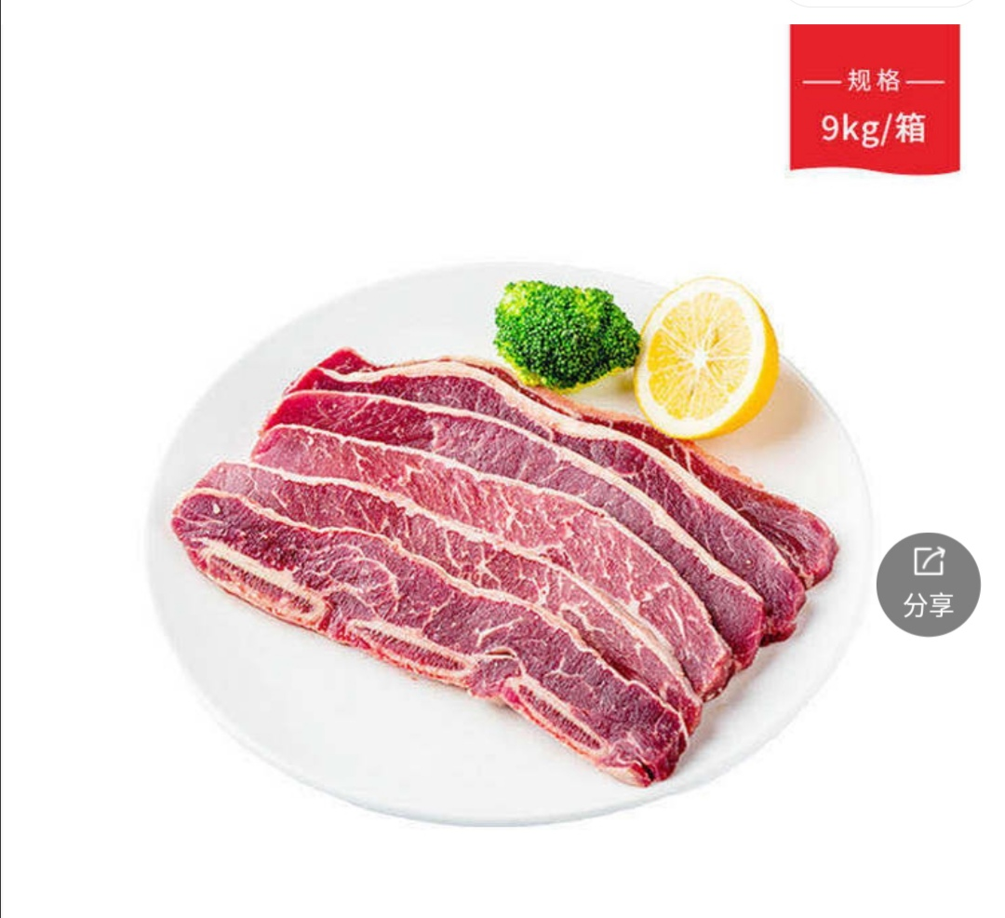牛仔骨150g/包 16.8 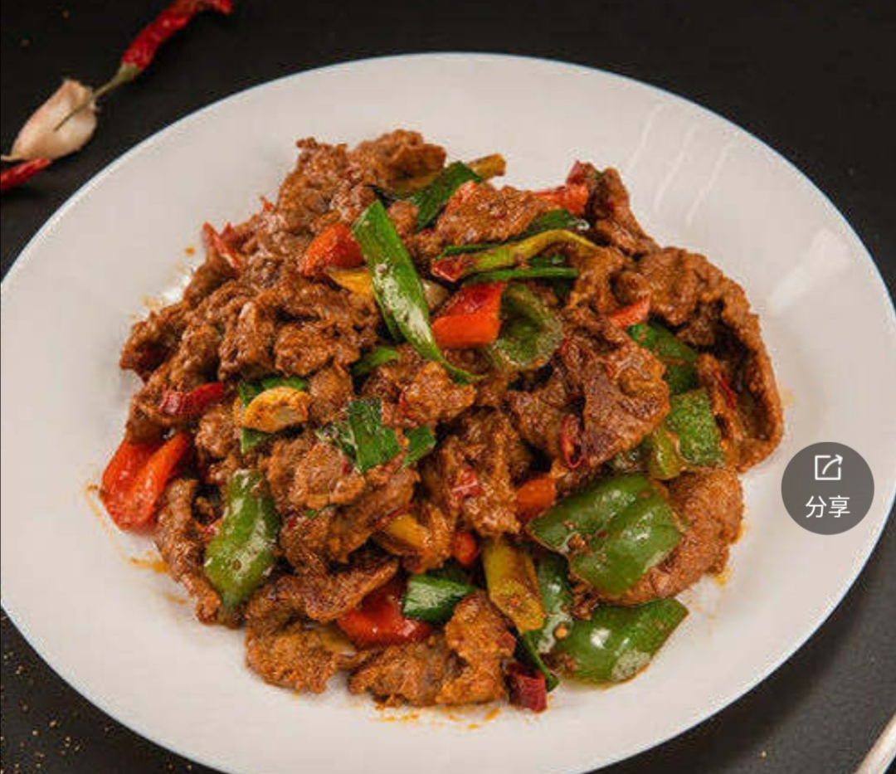面酱碎牛肉2斤一份/51.8
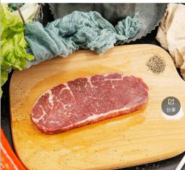新西兰雪花牛排150g一份/15.8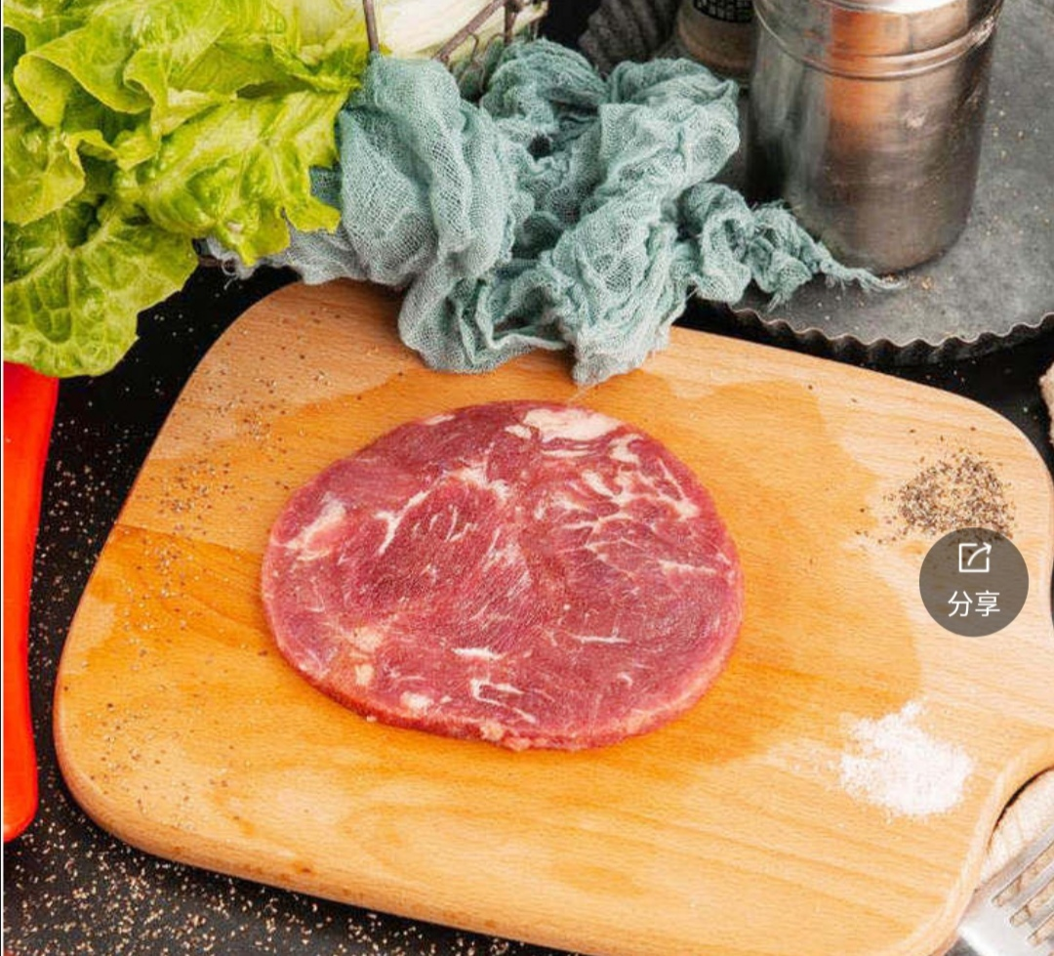佳味儿牛排2块/份16.88

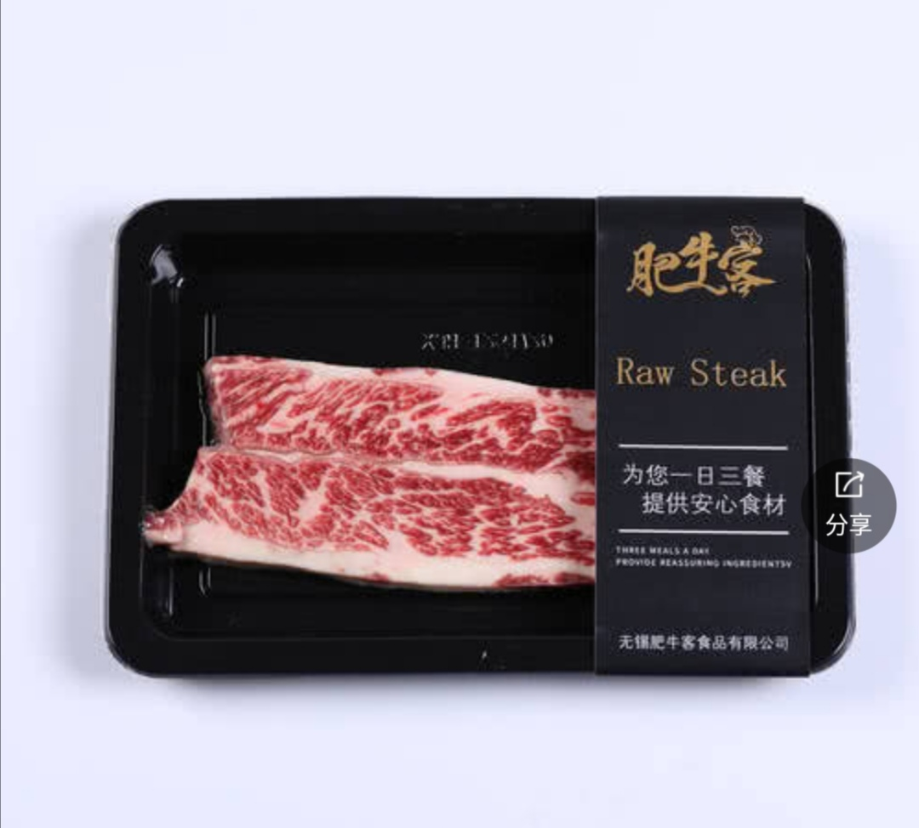谷饲牛柳150g一片/35.8 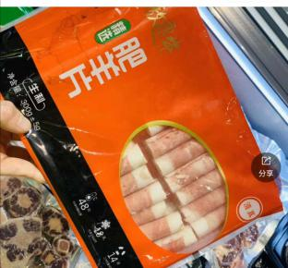精装肥牛卷300g/包 22.8
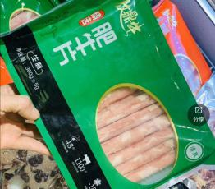精装肥牛卷300g/包 22.5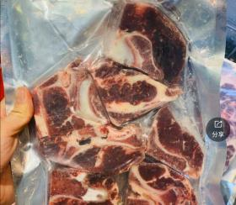牛脖骨500g/22.5

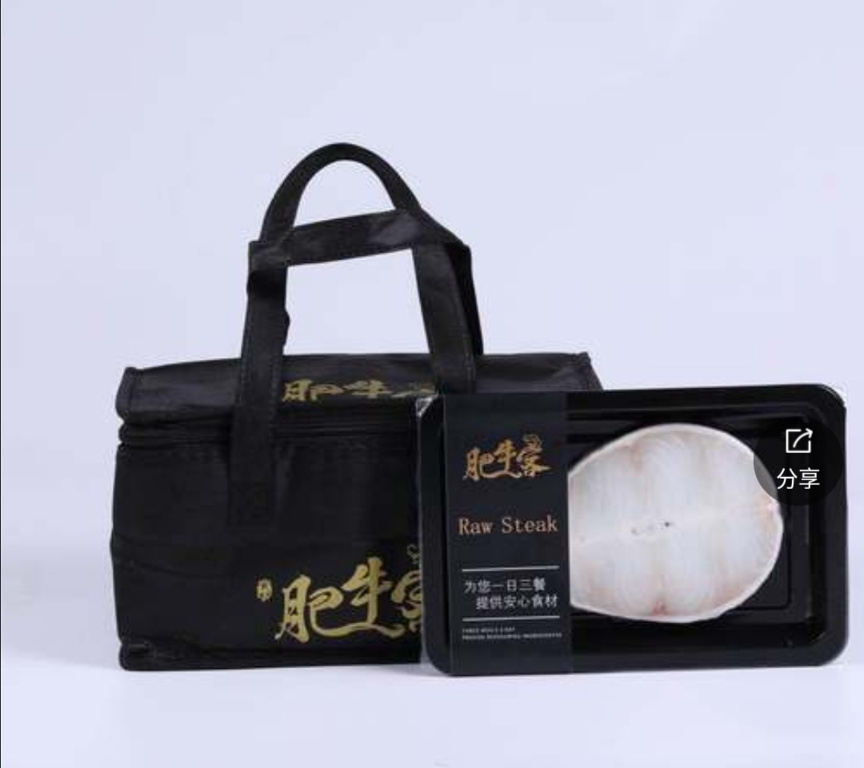谷饲鳕鱼150g/55.8 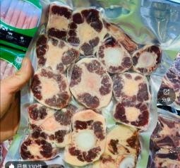牛尾500g/43.8
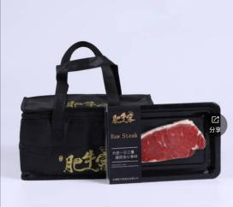谷饲西冷150g/22.8 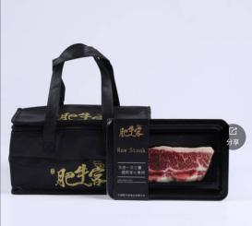谷饲上脑150g/22.8
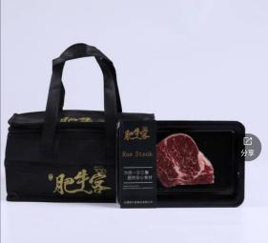谷饲眼肉150g/22.8谷饲板腱150g/37.5
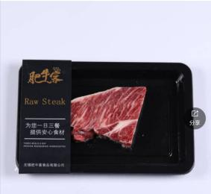雪花小排150g/55.8

